**Title: University Network Infrastructure Enhancement**

**Abstract:**

This report outlines strategies to improve the network infrastructure of university. With a focus on meeting current and future needs across different departments the proposed improvements span routing, security, management, design, troubleshooting, virtualization and automation. The objective is to create a network that is adaptable, scalable and resilient to support the varied demands of academic and administrative functions.

Table of Contents

Introduction: 2

Project Background: 2

State-of-the-Art: 2

Project Design: 3

Project Implementation: 4

Router 0 Configuration: 4

Router 1 Configuration: 5

Test of the Completed Network: 6

Conclusion: 7

References: 8

Table of Figures

Figure 1: Network Topology Design. 3

Figure 2: Router 0 Configuration. 4

Figure 3: Router 1 Configuration. 5

Figure 4: Ping command from PC0 to PC2, PC1 and DHCP Server. 6

Figure 5: Router 0 IP Route. 7

Figure 6: Router 1 IP Route. 7

# Introduction:

In an era where technology shapes the landscape of education the significance of a robust and adaptable network cannot be overstated. This report serves as a compass guiding university through the details of upgrading its network to meet the developing demands of academia and administration. As we navigate the complexities of modern education, the need for a network that seamlessly integrates cutting-edge technologies becomes increasingly evident. University, a beacon of academic excellence recognizes the pivotal role technology plays in enhancing the educational experience and administrative efficiency. The objective of this report is to present a comprehensive strategy for the improvement of our network infrastructure. Departments such as Academic Affairs, IT, Student Services and Administrative and Finance each contributing uniquely to the university's objective, pose different challenges and requirements. It is within this dynamic context that we embark on a journey to design a network that not only rectifies current limitations but also anticipates and accommodates the technological shifts of the future.

# Project Background:

As university continues to grow, so do the challenges faced by its current network infrastructure. Departments such as Academic Affairs, IT, Student Services and Administrative and Finance have different needs and the existing system, while robust in its foundations requires modernization to keep pace with technological advancements. This project is a response to those challenges, seeking to build a network that not only addresses immediate issues but also anticipates and accommodates future technological shifts.

# State-of-the-Art:

In the ever-evolving landscape of network infrastructure, staying abreast of state-of-the-art technologies and practices is paramount. The current state-of-the-art represents a convergence of advancements across various domains each contributing to the efficiency, security and adaptability of network systems. As we embark on enhancing the network infrastructure for university, it is important to understand and integrate these cutting-edge trends.

**1. Routing Technologies:** State-of-the-art routing protocols highlight active adaptability and efficient traffic management. Protocols such as OSPF and BGP, increased by segment routing, promise enhanced scalability and optimized routing paths ensuring unified communication across university's diverse departments.

**2. Security:** Cybersecurity is important in safeguarding sensitive academic and administrative data. The latest state-of-the-art includes multifactor authentication. Implementing these measures ensures a robust defense against evolving cyber threats providing a secure network environment.

**3. Design Principles:** Current design principles emphasize modularity, scalability and flexibility. Software-defined networking (SDN) and intent-based networking (IBN) concepts facilitate centralized control and programmability allowing for agile adjustments to network configurations based on varying departmental needs.

**4. Troubleshooting Mechanisms:** State-of-the-art troubleshooting involves real time network monitoring and analysis. Tools like packet capture and flow analysis contributes to rapid issue identification and resolution, minimizing disruptions in connectivity and services.

**5. Virtualization and Automation:** Virtualization technologies, including server and network virtualization coupled with automation frameworks simplify resource provisioning and maintenance tasks. This not only improves resource utilization but also accelerates the deployment of new services.

# Project Design:

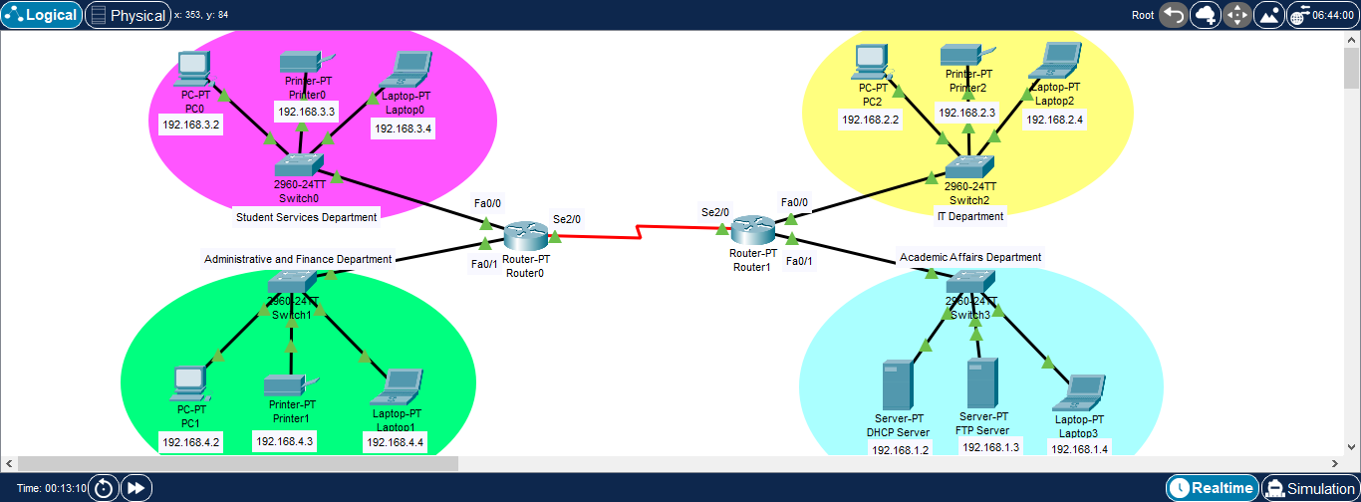

Figure : Network Topology Design.

# Project Implementation:

## Router 0 Configuration:

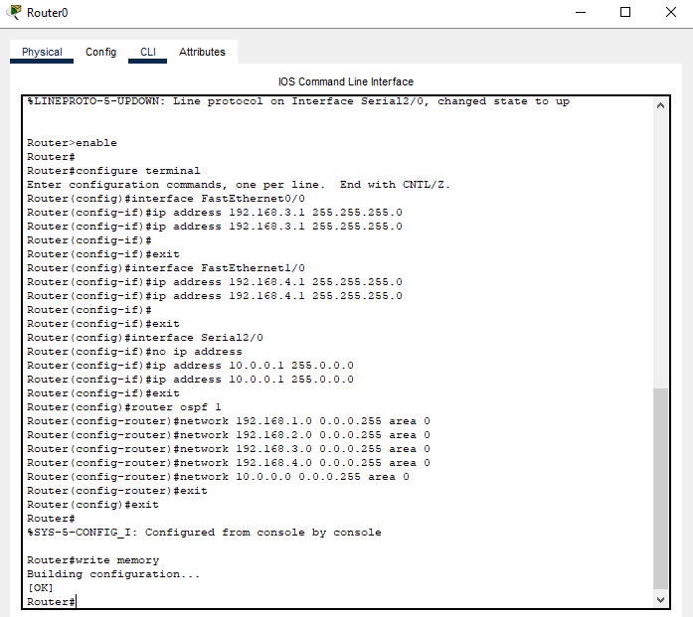

Figure : Router 0 Configuration.

## Router 1 Configuration:

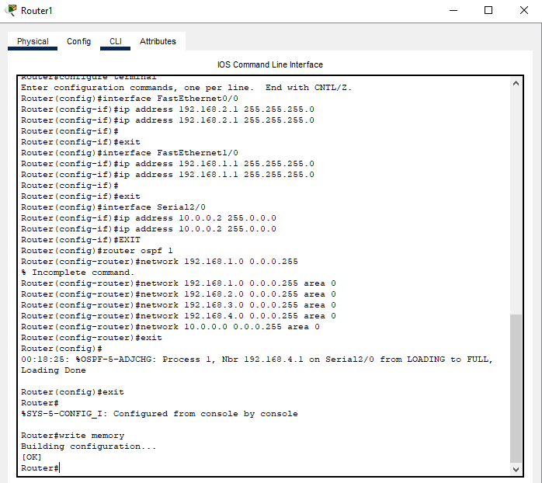

Figure : Router 1 Configuration.

## Test of the Completed Network:

**Ping command from PC0 to PC2, PC1 and DHCP Server:**

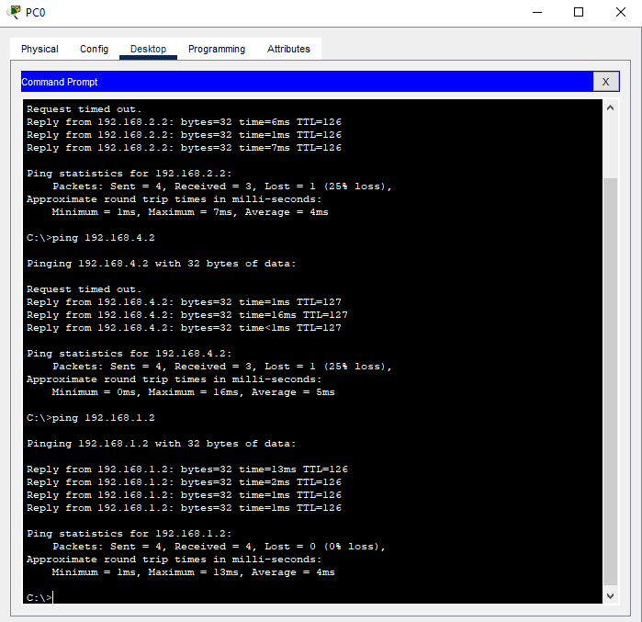

Figure : Ping command from PC0 to PC2, PC1 and DHCP Server.

**Router 0 IP Route:**

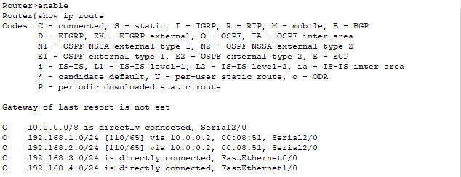

Figure : Router 0 IP Route.

**Router 1 IP Route:**

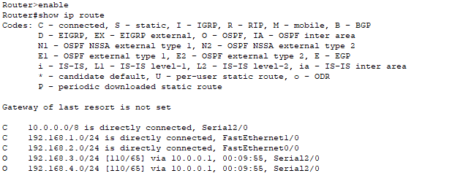

Figure : Router 1 IP Route.

# Conclusion:

In conclusion, the proposed network enhancements for university represent a important step towards a more adaptive and resilient infrastructure. By incorporating the latest technologies and addressing departments specific needs, we anticipate improved connectivity, security and overall efficiency. This initiative aligns with the university's commitment to providing a cutting-edge educational experience, ensuring that our network remains a reliable and innovative foundation for academic and administrative operations.

# References:

1. Tanenbaum, A. S., & Wetherall, D. J. (2018). Computer Networks (7th ed.). Pearson.
2. Kurose, J. F., & Ross, K. W. (2017). Computer Networking: A Top-Down Approach (7th ed.). Pearson.
3. Cisco. (2022). Cisco Certified Network Associate (CCNA) Routing and Switching Study Guide. Wiley.
4. Microsoft. (2022). Microsoft Certified: Azure Solutions Architect Expert Study Guide. Wiley.
5. Al-Fuqaha, A., Guizani, M., Mohammadi, M., Aledhari, M., & Ayyash, M. (2015). Internet of Things: A Survey on Enabling Technologies, Protocols, and Applications. IEEE Communications Surveys & Tutorials, 17(4), 2347-2376.
6. Zhang, Y., Lee, W., & Huang, C. (2018). Network Anomaly Detection and Analysis in Intrusion Detection Systems—A Survey. IEEE Access, 6, 59646-59656.
7. Gartner. (2022). Magic Quadrant for Network Performance Monitoring and Diagnostics. Gartner.
8. Kreutz, D., Ramos, F. M. V., Verissimo, P. E., Rothenberg, C. E., Azodolmolky, S., & Uhlig, S. (2015). Software-Defined Networking: A Comprehensive Survey. Proceedings of the IEEE, 103(1), 14-76.